Project Summary

This project uses the Linguacuisine app, designed by Newcastle University, to learn Spanish whilst cooking a Spanish recipe. Year 10 students use the app to cook a Spanish recipe and then develop their own recipe, video themselves cooking and giving instructions. Younger students would then use the video to cook and learn the language.

Linguacuisine
Seaham High School

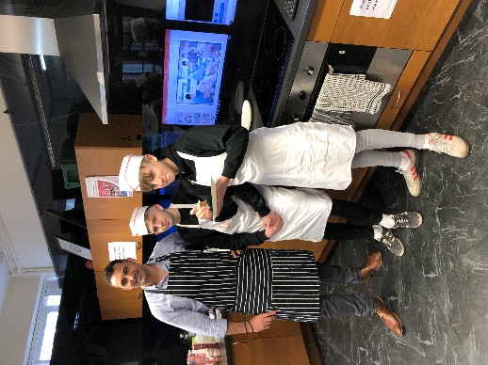
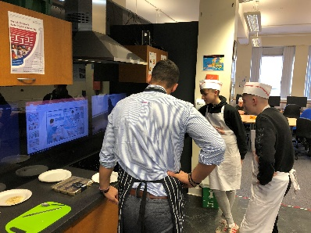
Cultural capital

As an entry event, the students attended a Linguacuisine session where they worked with a Spanish native speaker and used the Linguacuisine app to understand Spanish instructions to make a classic Spanish recipe. They tried the food and discussed the differences between Spanish and English food and made a tapas menu by researching classic tapas dishes online.
They also visited the Language Resource Centre where they were challenged to use the resources to research key vocabulary in a wide range of languages, most of which were unknown to them.
Back at school, students were planning to make a simple Spanish recipe and video themselves preparing it and giving instructions. Younger students would then follow the instructions to prepare the recipe. This was linked to some of the students visiting Spain in the summer term.

Skill development

- -Developing vocabulary, grammar and cultural knowledge
- ·Using ICT (Video, iPads, app)
- ·Working independently and in a group
- ·Creating a final product (video recipe)
- ·Communicating ideas, cultural knowledge and vocabulary to an external audience via video instruction

National Curriculum subject content

Year 10 MFL (Spanish) Curriculum: Developing linguistic competence, cultural appreciation and knowledge, and vocabulary
KS3 MFL: enable pupils to understand and communicate personal and factual information that goes beyond their immediate needs and interests; listen to a variety of forms of spoken language to obtain information and respond appropriately; speak coherently and confidently, with increasingly accurate pronunciation and intonation

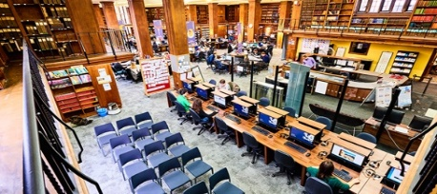
Gatsby Benchmarks

BM4. Linking curriculum learning to careers​ BM 5: Encounters with employers and employees​ BM 6: Experience of workplaces​ BM7: Encounters with further and higher education​
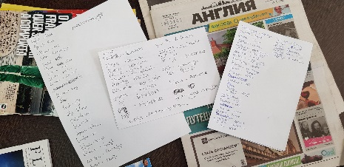

Week 1 | Week 2 | Week 3 | Week 4 | Week 5 | Week 6 | Week 7
Students visit Newcastle University to take part in Linguacuisine and do research in the Language Resource Centre. Supported by Linguacuisine team | Students develop their own recipes and video themselves cooking and giving instructions in Spanish.  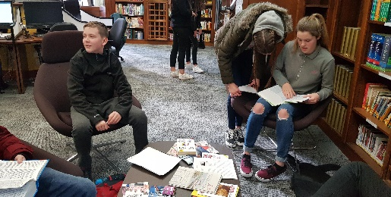  Delivered by MFL department with support from Newcastle University and Linguacuisine app |  |  |  | Yr 8 students use the videos to make the recipes  Delivered by MFL department with support from Newcastle University and Linguacuisine app | Showcase: Yr 8 and Yr 10 students hold a showcase to invited guests where they help guests to cook using the videos/app.  External audience: parents,  university researchers
Useful links/resources/ideas

Newcastle University Language Resource Centre: https://www.ncl.ac.uk/language-resource-centre/
Linguacuisine, Newcastle University: https://linguacuisine.com
If your school isn’t near Newcastle, find your local university/college outreach teams.
Resources relating to this specific project on our website.
General resources on our website: blank planning tools, links to useful websites, more case studies
Launch event/ Final product and showcase

The project launched with a visit to the LRC. This introduced them to a university environment and showed them how MFL is taught at university. They also took part in a Linguacuisine session where they used a free app to learn Spanish whilst cooking an authentic recipe.
The aim of the project was to introduce the students to Spanish culture in a context outside a typical classroom, using an authentic situation and a native speaker to teach the related vocabulary and get the students talking to one another in the target language.
The showcase event planned to invite external partners, parents and grandparents to the school where the Head of MFL would discuss the importance of languages in the world of work. Students would then present their videos with audience interaction, as audience members attempted to cook the recipes.
Project activity and timescale

